Clean up and push back to remote Git

- Verify master is in clean state
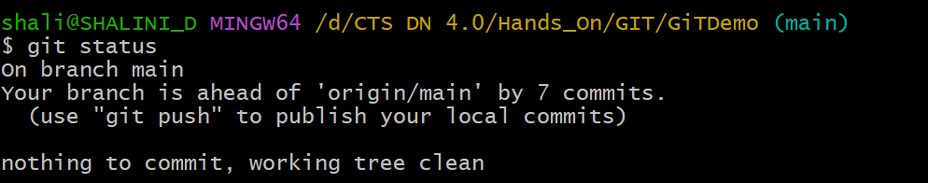

- List all available branches
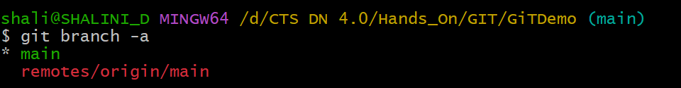

- Pull the latest from remote into main
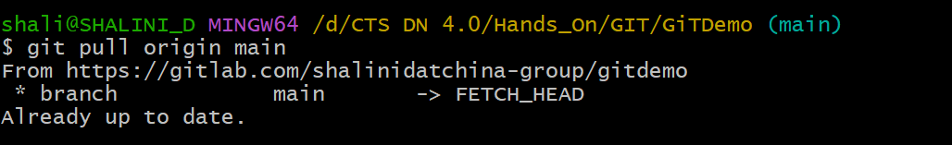

- Push the changes to the remote Git repository
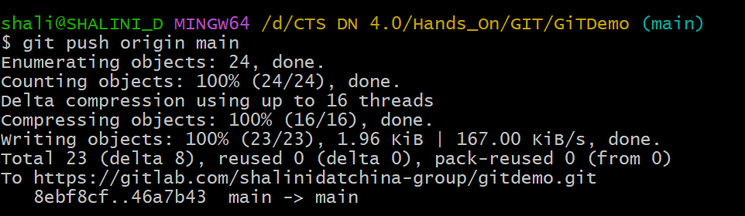

- Verify changes on remote
